**Bowling action legality analysis in cricket**



Session: 2021 – 2024

**Submitted by:**

Muhammad Danish 2021-CS-167

**Submitted to:**

**Sir Samyan Wahla**

Department of Computer Science

**University of Engineering and Technology**

**Lahore Pakistan**

**Introduction:**

As we all know, now a day’s Cricket is very most popular sport all over the world. Cricket is a bat-and-ball sport which is played between two teams on a cricket ground. Each team consists of eleven players. At the center of the cricket ground is a twenty two yard rectangular pitch with a set of three vertical wooden posts at each end called wicket. The team designated for batting, always has two players on the pitch called batsmen while the opponent team ﬁelds its eleven players. The match begins when a bowler, a designated player of the ﬁelding team, runs towards his wicket and bowls the ball from one end of the pitch towards the batsman standing in front of the wicket at the other end. The batsman’s intention is to prevent the ball from hitting the wickets with his bat and score as many runs as possible with the bat after hitting the ball. The bowler attempts to both stop the batsman from scoring the runs and to dismiss the batsman. The dismissed batsman is replaced by another player of his team at the pitch. The batsman is dismissed by a bowler when he is bowled, the batsman failed to prevent the ball from hitting the stumps, leg before wicket, when the bowler hits the batsman with the ball in front of the stumps without touching the bat, and caught, when the ball goes into the air after touching batsman’s bat and is caught by a fielder before touching the ground. There are two phases in the cricket game, each called an innings. An inning is completed either when a defined limit of overs has been reached or the ten batsmen of the batting team have been dismissed. The batting team then becomes the bowling team and vice versa. The team running the most score is declared the winner. The International Cricket Council (ICC) and Marylebone Cricket Club (MCC) maintain the laws of cricket. The bowler is restricted to deliver the ball overarm with a straight arm and cannot throw the ball. If the bowler bends his arm, the other team is given one run and he has to bowl the ball again.(Saad Qaisar 2017) addressed the issue of legality of bowling action of fast bowlers by using sensors putting on the different part of the bowler arm.

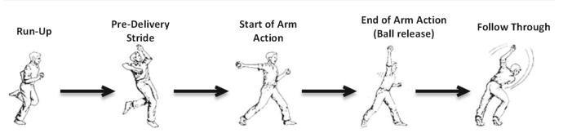

# **Fig. 1** Key events of bowling action

**Problem and Goal with Previous Research Work:**

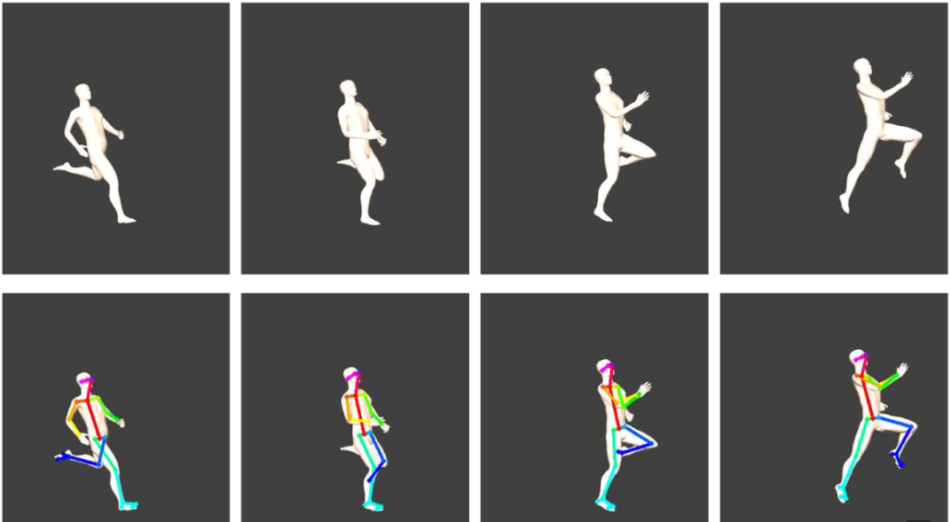A recent research work (Ahmed et al. 2015) used flex sensors to check the validity of bowling action by measuring arm angle at ball release. However, it does not discuss specific points of bowling action particularly the carry angle, the start of the arm action is not identified and the critical aspect of elbow extension is not monitored between the start and the end of the arm action. Therefore, a simple orientation based detection. (M.Salman 2017) develop different profiles of the events that can be used to assess the legality of the bowling action, as well as analyze the arm extension. The key events in a bowling action are run-up, pre-delivery stride, the start of the arm action, the end of the arm action (ball release), and follow through, as shown in Fig. 1. The movements performed by an athlete during the key events may or may not follow the standards set by the regularity authority. For example, the problem with arm movement during the arm actions may include extending the arm beyond an angle of 15◦.

We want to identify either the bowling action is correct or not. Our aim is to develop a system in which we capture video footage of the bowling action, preferably from multiple angles for comprehensive analysis and we will use OpenPose to estimate the general pose of bowler such as the angle of the arm, position of the elbow, and the sequence of movements.

**Fig.2** Follow through of bowler

**Solution:**

We found the solution to detect the legality of bowling action using pose detection of human arms and then detecting the specific landmarks of arms which includes (shoulder, wrist, and elbow) with further detecting the angle between these three landmarks on releasing the ball and on just before arm become vertical to release the ball. According to ICC (International Cricket Council) bowler can band the arm less or equal to 15 degree just before make the arm horizontal to release the ball. I make BowlAction desktop app in which user can input the front on bowler video and so then analyze the bowling action and result.

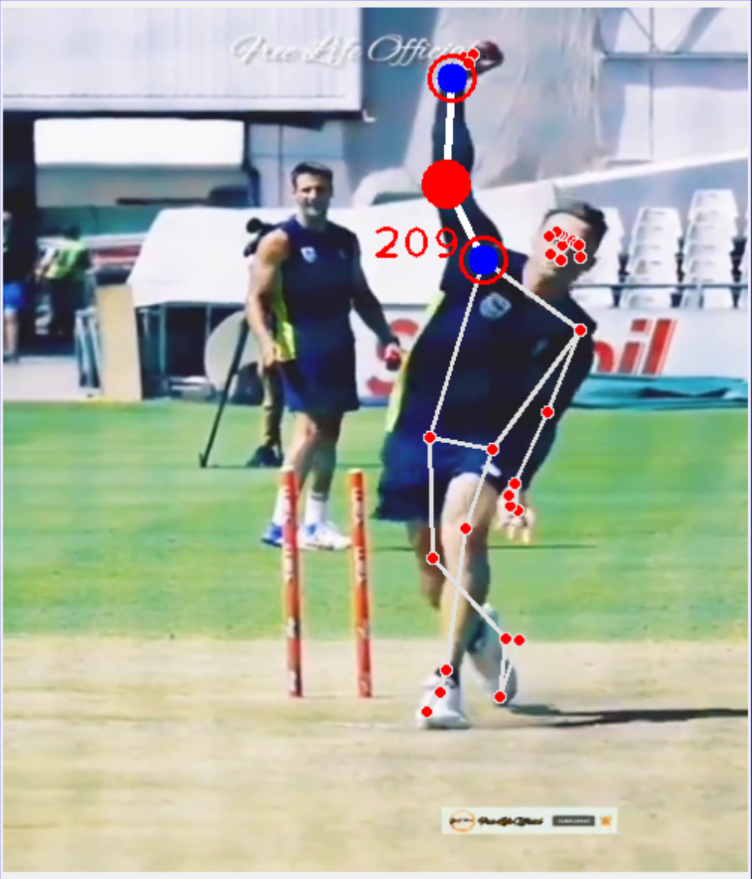

**Fig.3** Angle of bowler arm just before arm becoming vertical

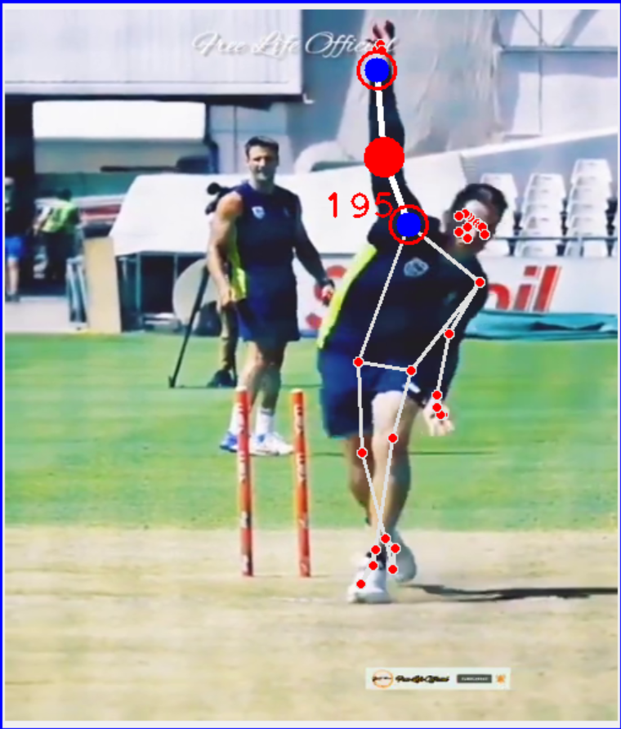

**Fig.3** Approximate angle of bowler arm when ball going to be release it may be little change when ball finally release.

**Fig.4 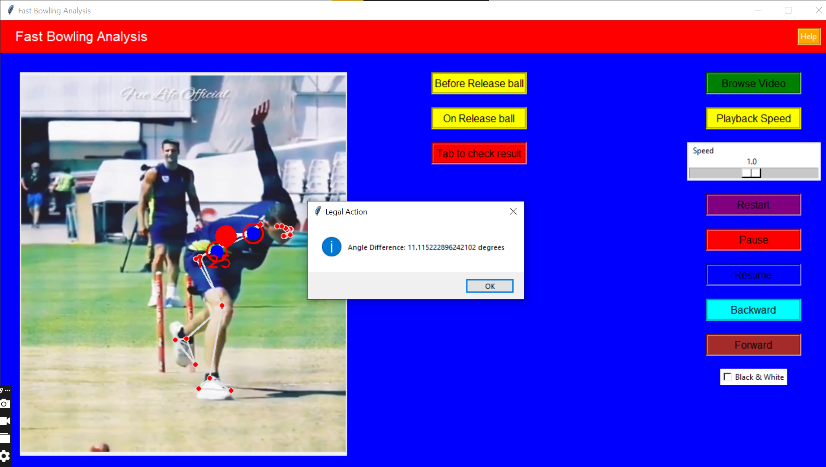**Final result analysis

**BowlAction User Interface:**

I implement a simple user interface in which we have multiple button for specific purpose. We have ‘Browse Video’ button to input video from PC, ‘Playback Speed’ to control the speed of video from 0.1 to 2.0, ‘Restart’ to restart to video from beginning, ‘Pause’ to stop the video at any point, ‘Resume’ the replay the pause video, ‘Backward’ to backward the video, ‘Forward’ to forward the video, ‘Before Release ball’ to calculate angle just before arm becoming vertical and this done by user itself there is large number of chances that user can make error in analyzing arm angle on specific point, ‘On Release ball’ to calculate angle on releasing the ball in which user can also make error, ‘Tab to check result’ to check whether the action is legal or not.

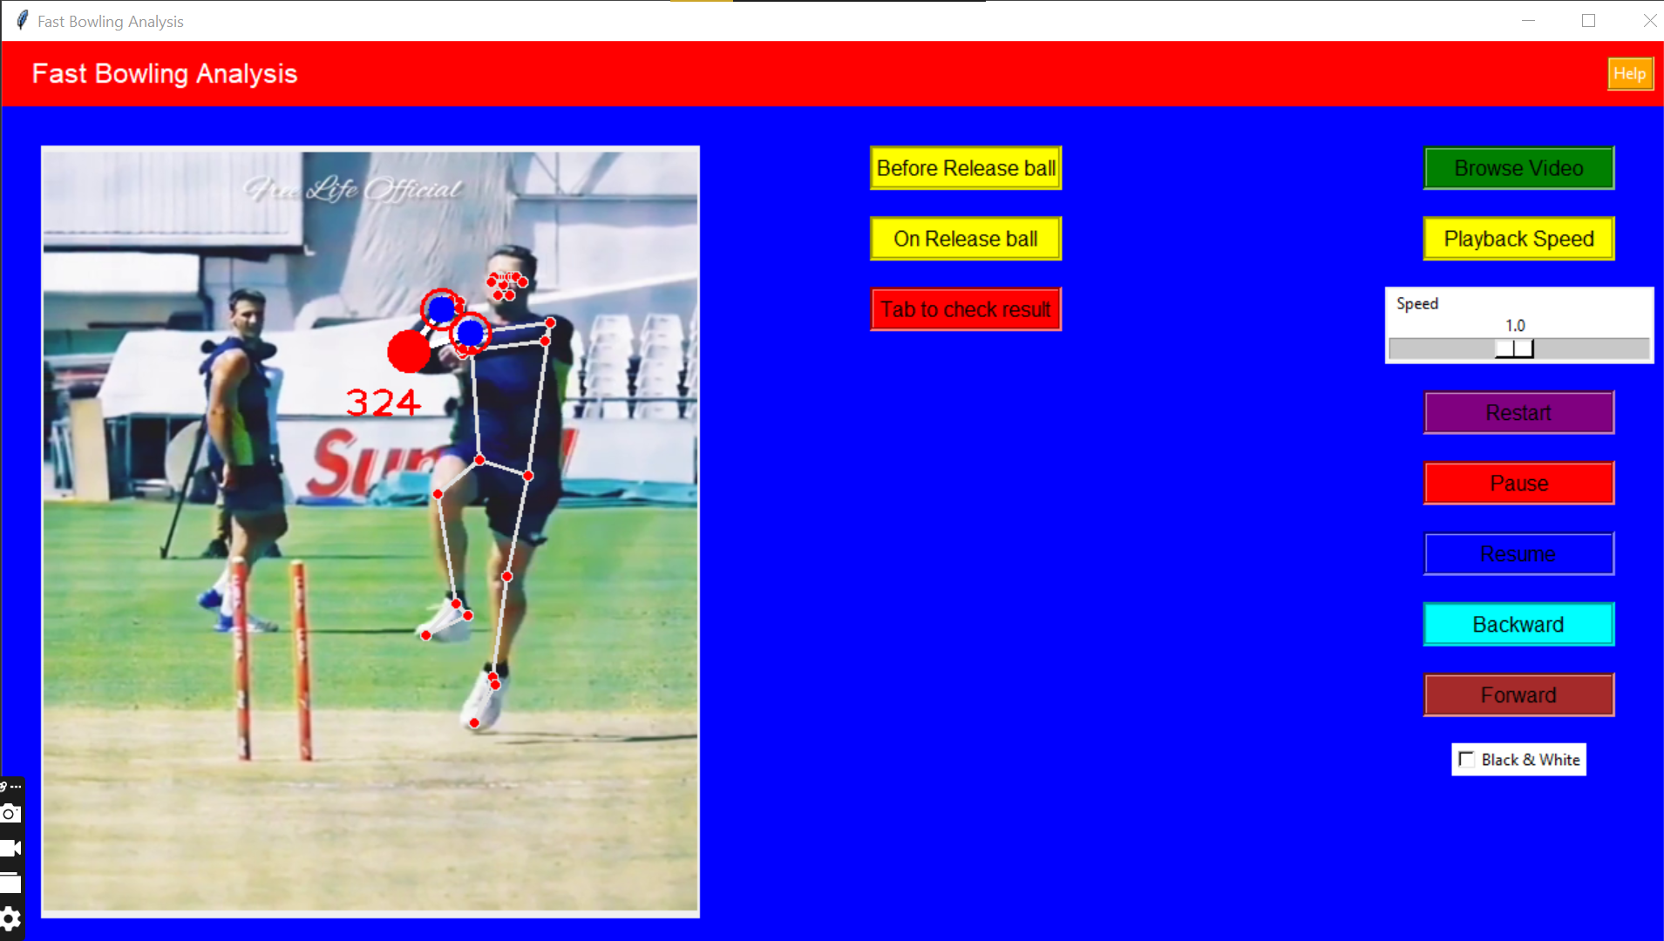 **Fig.5** User Interface of BowlAction App

**Limitations:**

This system is currently going through further field testing so that we can train our system with defined parameters to get better accuracy. This system is currently detect chucking only. Currently, we just manually analysis the bowler arm angle just before releasing the ball and on releasing the ball. This system also cause human error in analyzing the angle on the right point in the video. This system should be able to analyzing the angle on the specific point automatically by analyzing when ball is going to be release and when arm going to be vertical.

**Conclusion and future work:**

In this proposal, we have addressed the problem of detecting the legality of a bowling action in the game of cricket. For this purpose, we make BowlAction in which we analysis the bowler’s armso that users can input video footage, view analysis results.

Future works include the development of a system to automatically detecting the releasing point of ball and follow through of arm to become vertical.The accuracy of the system could may be further improved with other approaches.

**References:**

# Ahmed A, Asawal M, Khan MJ, Cheema HM (2015) A wearable wireless sensor for real time validation of bowling action in cricket. In: IEEE 12th international conference on wearable and implantable body sensor networks (BSN), 2015. IEEE, pp 1–5.

# Muhammad Salman, Saad Qaisar, Ali Mustafa Qamar (2017) Classification and legality analysis of bowling action in the game of cricket, 2017.

wicket. The team designated for batting, always has two players on the pitch called

batsmen while the opponent team ﬁelds its eleven players. The match begins when a

bowler, a designated player of the ﬁelding team, runs towards his wicket and bowls the

ball from one end of the pitch towards the batsman standing in front of the wicket at the

other end.

Cricket is a bat-and-ball sport which is played between two teams on a cricket ground.

Each team consists of eleven players. At the centre of the cricket ground is a twenty

two yard rectangular pitch with a set of three vertical wooden posts at each end called

wicket. The team designated for batting, always has two players on the pitch called

batsmen while the opponent team ﬁelds its eleven players. The match begins when a

bowler, a designated player of the ﬁelding team, runs towards his wicket and bowls the

ball from one end of the pitch towards the batsman standing in front of the wicket at the